Hi, this document will explain how to access the server-side and client-side of Sirimiri Chatbot.

**Client-Side**

For the client-side, as we have already deployed the system, users only need to add

**+1 (415) 319-9749** to your handphone contact and start using it.

If you are unsure of how the conversation will begin, please refer to the below screenshot. Please note that due to time constraints, the final system developed might not account for all scenarios. For example, there will be receipts where the OCR is unable to recognize. Hence, for demonstration purposes, please use the Receipt.jpg in the folder.

A screenshot of the conversation with the AI chatbot is attached below.

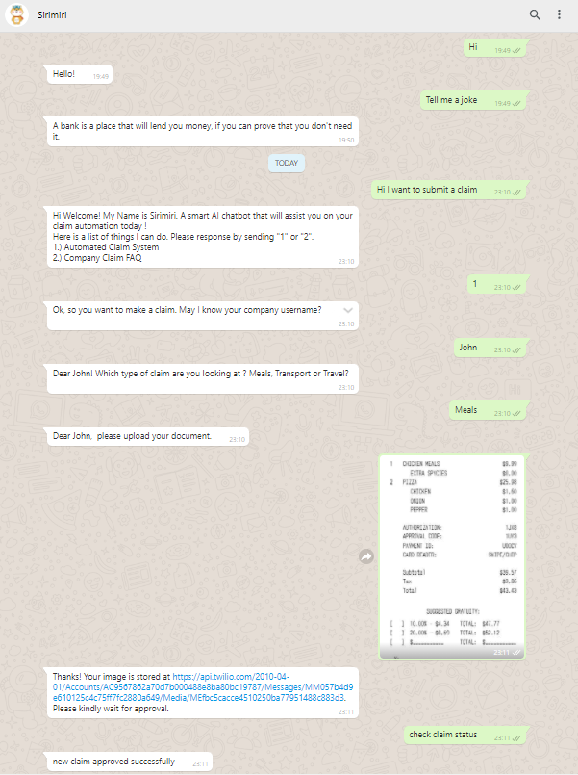

**Server-Side**

For the server-side, please download sirimiri_chatbot.rdp and login using password : $DFiJLT;$*vvCXjEfxl-THaKP?@EP)ay

There will be the code for the deployment of the WhatsApp chatbot and the setup for jBPM.

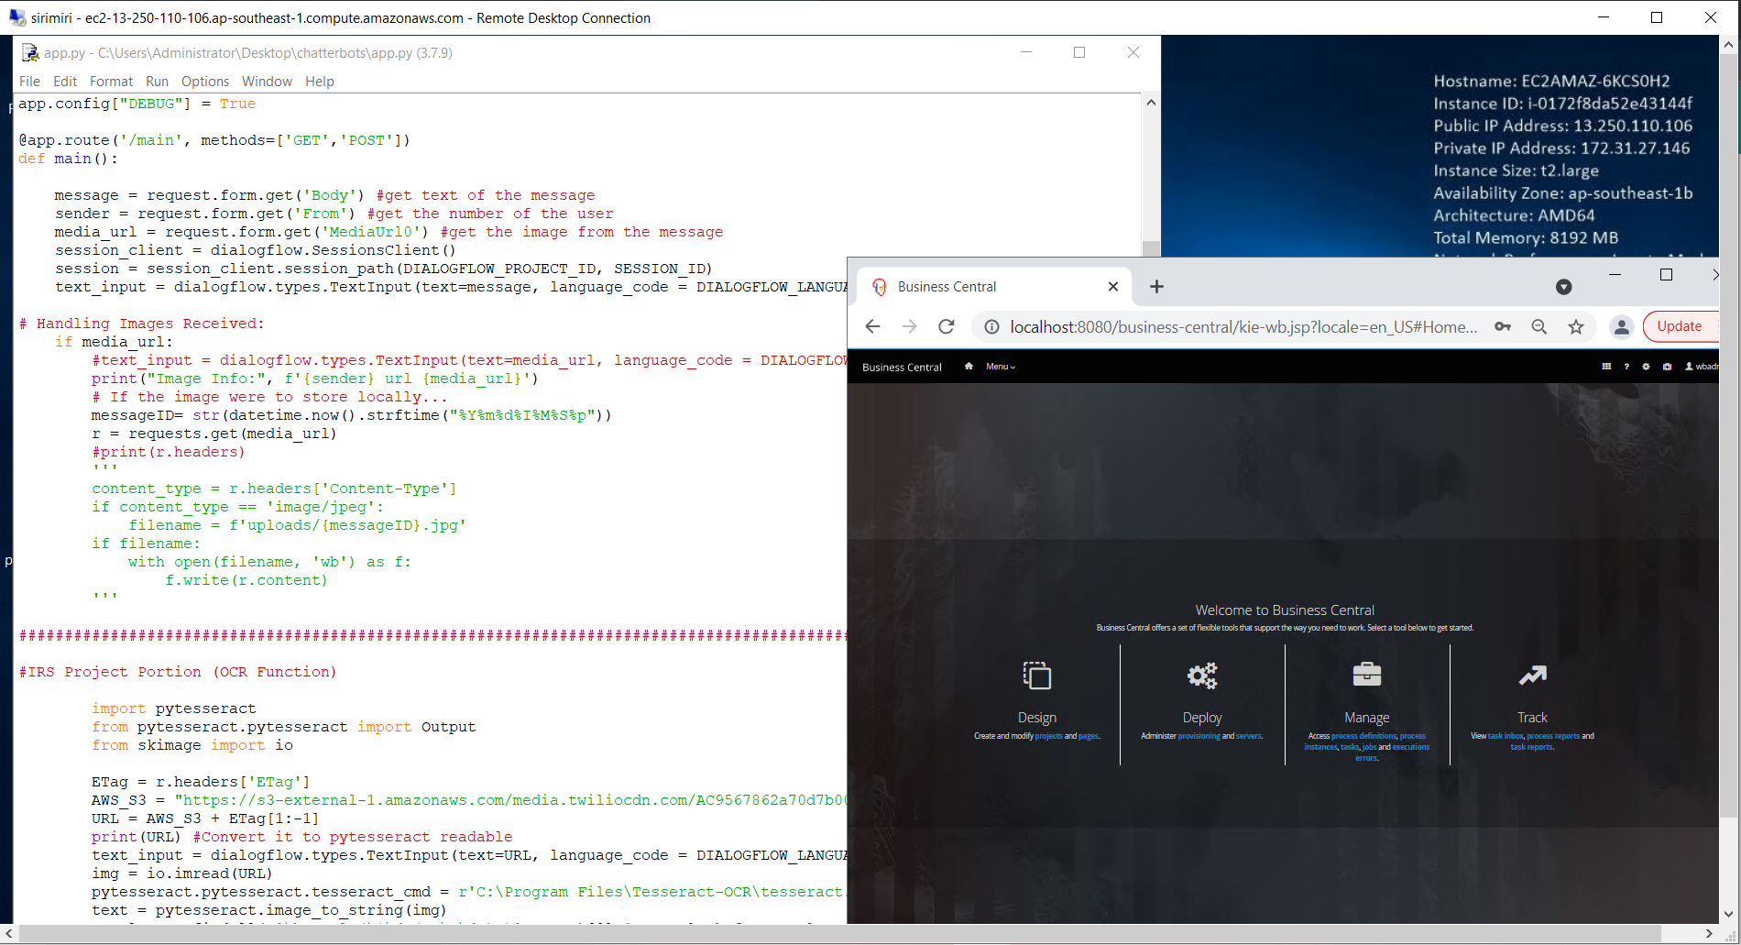

The below screenshot is the setup for the Dialogflow. We have also exported the Dialogflow as a zip folder sirimiri_dialogflow.zip

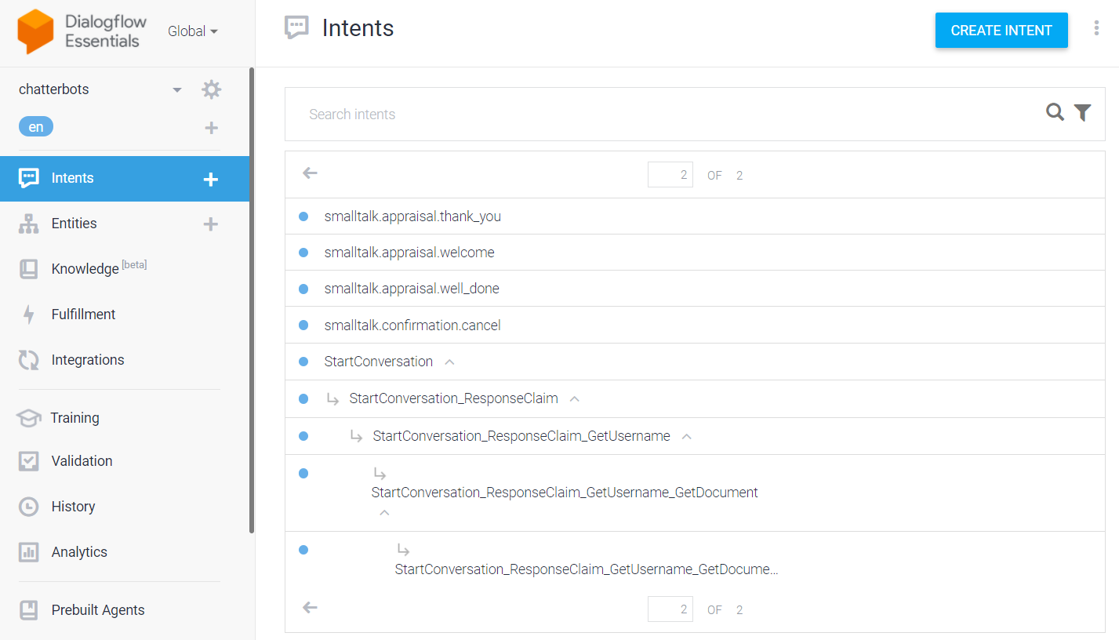

FAQs.csv is an excel that contains all the frequently asked questions to help users understand the claim system.

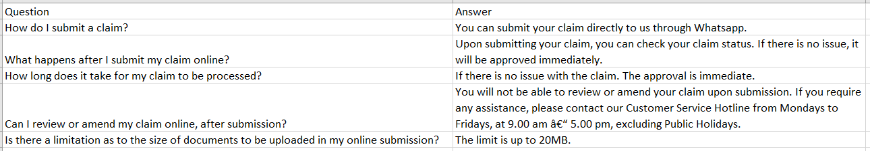

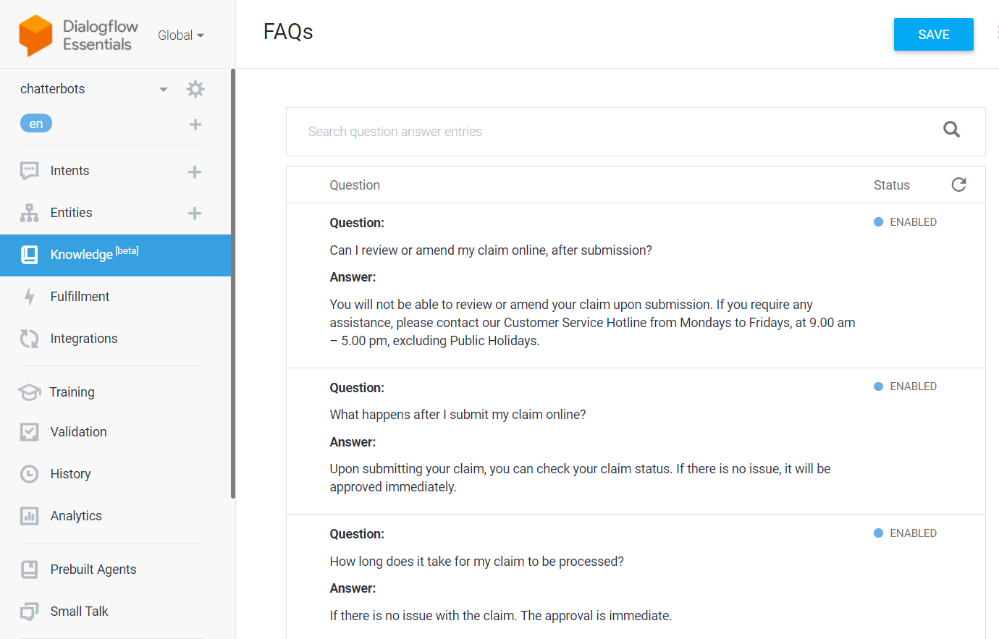

OCR  
  
Please refer to the Jupyter notebook (OCR.zip) for the code for OCR (Paddlepaddle/EasyOCR/Pytesseract).

Easy OCR

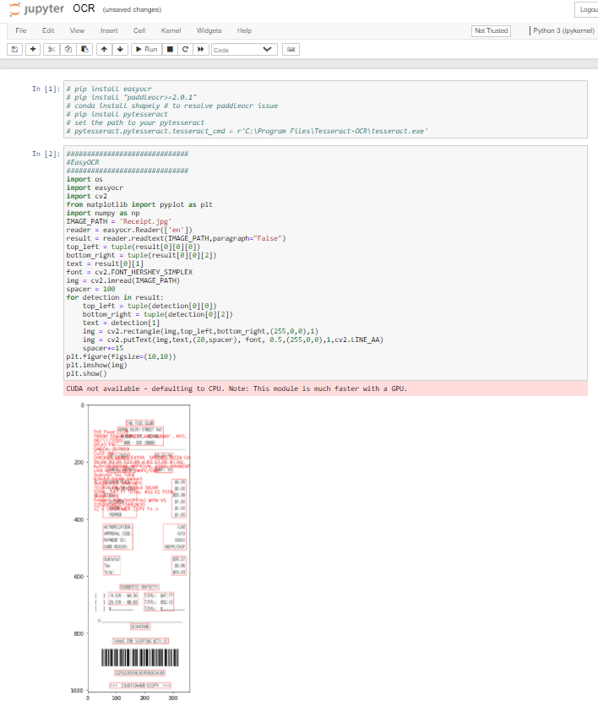

PaddleOCR

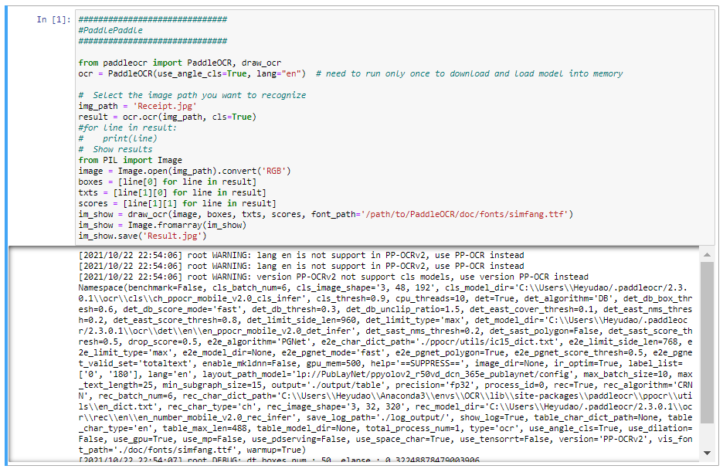

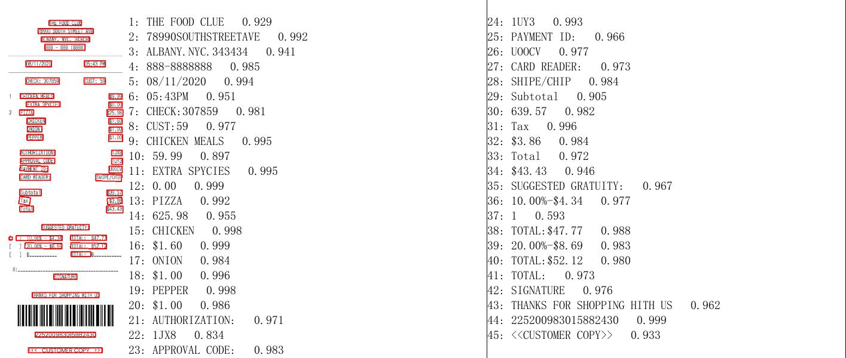

Pytesseract

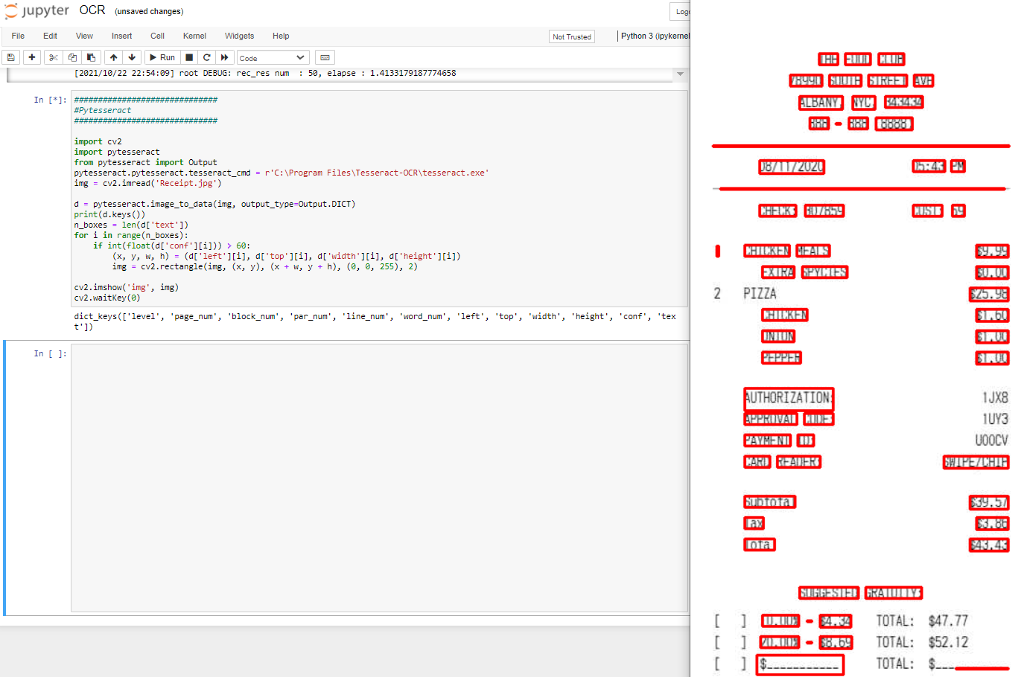

jBPM

The expenses claim system is built based on the jBPM system([jBPM - Open Source Business Automation Toolkit - jBPM Business Automation Toolkit](https://www.jbpm.org/)).

1. Install the jBPM

There are two suggested methods to install the above system, either on linux system or windows system which would be described in the following:

The easiest method to deploy a jBPM is through docker. If you are in a linux docker environment, simply(<https://www.jbpm.org/download/download.html#docker>) run the following command:

docker run -p 8080:8080 -p 8001:8001 -d --name jbpm-server-full jboss/jbpm-server-full:7.59.0.Final

If you are prefer a Windows system, download from

* download [Download jBPM 7.59.0.Final server (single zip) distribution](https://download.jboss.org/jbpm/release/7.59.0.Final/jbpm-server-7.59.0.Final-dist.zip)

After install java, just unzip the above and run

jbpm-server/bin/standalone.bat (Windows

If you are not familiar with docker, you can also unzip the above and run:

jbpm-server/bin/standalone.sh (Unix / Linux)

1. Import the expenses-claim-system

Once the jBPM server was started, Business Central can be accessed at [**http://localhost:8080/business-central**](http://localhost:8080/business-central)

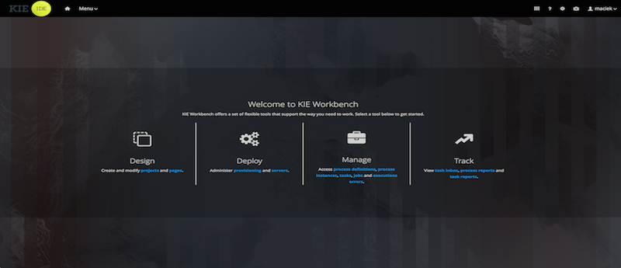

Select Design, then select the space named “ MySpace “; Click on “ Import Project ” button, and enter the following Repository URL (no authentication required): **Expenses_Claim_Process (import from this folder)**

Once the assets are loaded, click “Deploy”.

The expenses claim system is ready after deployment is completed!